Week 6
1. Two Issues
I encountered some problems when attempting to perform training on the USask server, which can be classified into two main issues.

1.1 GPU Compatibility
During the YOLO26n GPU setup on Plato, the main issue was PyTorch compatibility with the assigned GPU. The node platogpu007 uses an NVIDIA RTX PRO 6000 Blackwell Server Edition MIG GPU with compute capability sm_120. However, the local PyTorch environments I tested did not support this architecture.
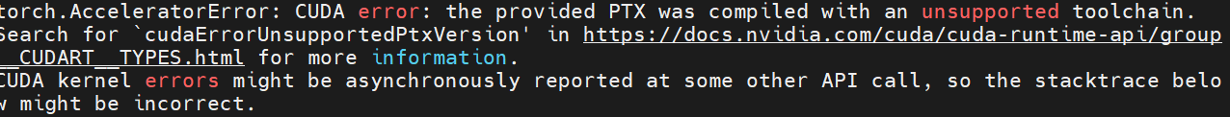
Figure 1.1: Toolchain Error

The first environment used PyTorch 2.9.0 with CUDA 12.6, which only supported sm_70, sm_80, and sm_90. A second Compute Canada wheelhouse environment used PyTorch 2.12.1 with CUDA 13.2, but it only supported sm_80, sm_90, sm_100, and compute_100. Since neither environment included sm_120, even a minimal CUDA tensor test failed before YOLO training could start.
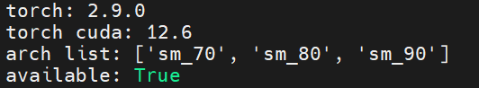
Figure 1.2: Torch 2.9 Arch List

The problem was solved by using the IT-provided Apptainer container:
/opt/software/apptainer-images/pytorch-25.06.sif
This container provides a PyTorch environment compatible with the Blackwell GPU.
Also, project-specific packages such as Ultralytics were installed into a separate user package directory and loaded through PYTHONPATH

1.2 Disk Quota
The home directory on Plato has a limited quota of 50 GB and 300,000 files, which is not ideal for large YOLO datasets, model weights, package directories, and training outputs.
Figure 1.3: Quota Error

The problem was solved by IT, who told me that I can use the folder project/ko/afm176. Large datasets, model weights, and training outputs will be stored under there instead of the limited home directory.

2. Model Full Train
The training was conducted using the baseline YOLO26n model on the converted MIO-TCD YOLO dataset. We use 11000 images, with a 70/15/15 split for training/validation/test. The model was trained for 100 epochs with an input image size of 640 x 640 and a batch size of 16.

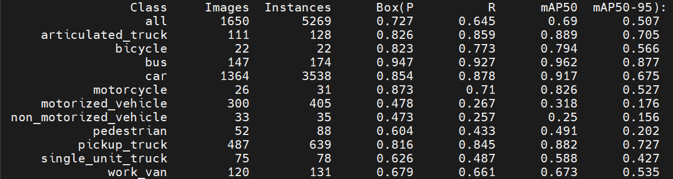
Figure 2.1: Training Results
Box(P) means bounding-box precision. It measures how many predicted boxes are correct.
R, or Recall, measures how many real objects are successfully detected.

According to Figure 2.1, the model reached a final precision of about 0.679, recall of about 0.666, mAP50 of about 0.677, and mAP50-95 of about 0.493 at epoch 100.

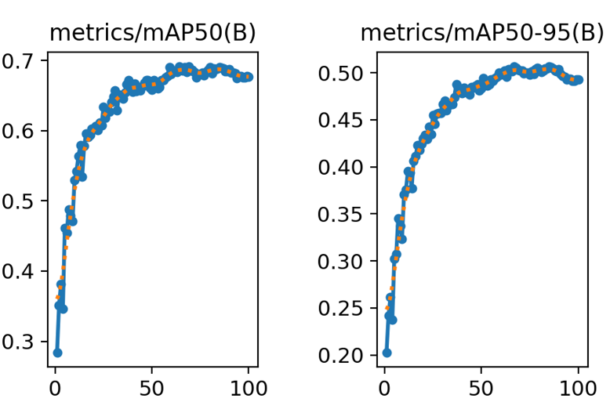
Figure 2.2: mAP / eopch
According to Figure 2.2, the best mAP50 appeared around epoch 64, reaching about 0.691, while the best mAP50-95 appeared around epoch 85, reaching about 0.507. After around 60 to 85 epochs, the improvement became slower and the curves started to plateau. This suggests that the model had mostly converged.

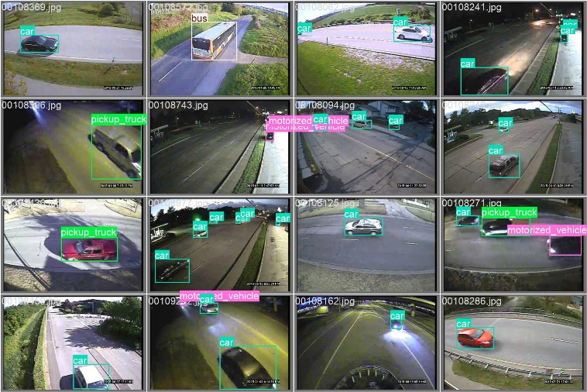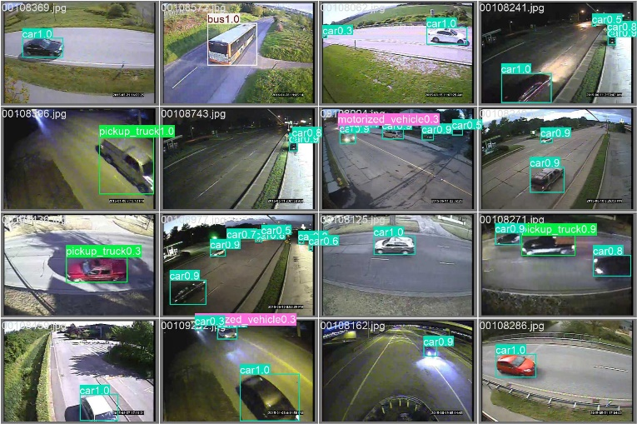
Figure 2.3: Ground Truth vs Predict Examples

3. Profiling
The purpose of profiling is to identify the main bottlenecks and measure the model speed.

3.1 Layer-based
Rank | Layer ID | Layer Type | Mean Latency (ms)
1 | 23 | Detect | 1.724
2 | 22 | C3k2 | 0.505
3 | 10 | C2PSA | 0.434
4 | 13 | C3k2 | 0.371
5 | 6 | C3k2 | 0.359
6 | 8 | C3k2 | 0.354
7 | 19 | C3k2 | 0.352
8 | 16 | C3k2 | 0.324
9 | 2 | C3k2 | 0.213
10 | 4 | C3k2 | 0.171
11 | 9 | SPPF | 0.121
12 | 0 | Conv | 0.118
13 | 3 | Conv | 0.078
14 | 1 | Conv | 0.076
15 | 5 | Conv | 0.071
16 | 7 | Conv | 0.054
17 | 20 | Conv | 0.049
18 | 17 | Conv | 0.049
19 | 11 | Upsample | 0.023
20 | 15 | Concat | 0.023
21 | 14 | Upsample | 0.022
22 | 12 | Concat | 0.018
23 | 18 | Concat | 0.016
24 | 21 | Concat | 0.015
Table 3.1: Layer-based Profiling Results
According to Table 3.1, the total measured model latency estimate was about 5.539ms. The main bottleneck was the C3k2 blocks. In total, the C3k2 layers contributed to about 2.649ms. The second major source of latency was the Detect layer, which required about 1.724ms.

3.2 End-to-end
Metric | Result
mAP50 | 0.690
mAP50-95 | 0.507
Preprocessing time | 0.243 ms/image
Inference time | 1.004 ms/image
Postprocessing time | 0.044 ms/image
Total latency | 1.292 ms/image
FPS | 774.168
CPU usage | 6.663%
Peak CUDA memory | 429.316 MB
Table 3.2: End-to-end Profiling Results
According to Table 3.2, inference is the largest part of the end-to-end latency, preprocessing and postprocessing are relatively small.
4. Error Injection
The experiment was repeated with different noise standard ratios from 0.1 to 1.0. When the noise ratio was low, the model performance only changed slightly. However, when the noise ratio increased, the mAP drop became larger.

Noise Std Ratio | Mean mAP50-95 Drop | Worst Layer | Worst Layer Type | Maximum mAP50-95 Drop
0.1 | 0.000032 | 3 | Conv | 0.001937
0.2 | 0.001217 | 0 | Conv | 0.010510
0.3 | 0.002921 | 0 | Conv | 0.027869
0.4 | 0.006197 | 0 | Conv | 0.060639
0.5 | 0.011693 | 0 | Conv | 0.113434
0.6 | 0.017879 | 0 | Conv | 0.167377
0.7 | 0.025373 | 0 | Conv | 0.225195
0.8 | 0.034353 | 0 | Conv | 0.279779
0.9 | 0.044256 | 0 | Conv | 0.333287
1.0 | 0.055542 | 0 | Conv | 0.377214
Table 4.1: Worst Layer in Different Noise Std Ratio
The result shows that Layer 0 Conv was the most sensitive layer in most noise settings.

Rank | Layer ID | Layer Type | mAP50-95 | mAP50 | mAP50-95 Drop | mAP50 Drop
1 | 0 | Conv | 0.129418 | 0.186596 | 0.377214 | 0.503459
2 | 1 | Conv | 0.301697 | 0.437431 | 0.204935 | 0.252624
3 | 3 | Conv | 0.334498 | 0.473960 | 0.172134 | 0.216095
4 | 22 | C3k2 | 0.442851 | 0.630629 | 0.063782 | 0.059426
5 | 19 | C3k2 | 0.445578 | 0.624095 | 0.061054 | 0.065961
6 | 16 | C3k2 | 0.451669 | 0.606830 | 0.054963 | 0.083225
7 | 8 | C3k2 | 0.465640 | 0.636539 | 0.040992 | 0.053517
8 | 5 | Conv | 0.466743 | 0.637374 | 0.039890 | 0.052681
9 | 9 | SPPF | 0.471878 | 0.643380 | 0.034754 | 0.046675
10 | 2 | C3k2 | 0.474561 | 0.650729 | 0.032072 | 0.039326
11 | 13 | C3k2 | 0.477476 | 0.665829 | 0.029157 | 0.024226
12 | 12 | Concat | 0.480080 | 0.660008 | 0.026552 | 0.030047
13 | 10 | C2PSA | 0.480587 | 0.657494 | 0.026045 | 0.032561
14 | 4 | C3k2 | 0.484197 | 0.670723 | 0.022436 | 0.019333
15 | 6 | C3k2 | 0.488420 | 0.662584 | 0.018213 | 0.027472
16 | 15 | Concat | 0.488623 | 0.673205 | 0.018009 | 0.016850
17 | 14 | Upsample | 0.492659 | 0.680166 | 0.013973 | 0.009889
18 | 11 | Upsample | 0.494212 | 0.677629 | 0.012420 | 0.012426
19 | 18 | Concat | 0.495438 | 0.681729 | 0.011195 | 0.008326
20 | 7 | Conv | 0.497987 | 0.678049 | 0.008646 | 0.012006
21 | 17 | Conv | 0.499871 | 0.684688 | 0.006762 | 0.005367
22 | 20 | Conv | 0.504555 | 0.688742 | 0.002077 | 0.001313
23 | 21 | Concat | 0.506439 | 0.690848 | 0.000193 | -0.000793
Table 4.2: Error Injection at Noise Std Ratio = 1.0
Layer 0, Layer 1, and Layer 3 are the most sensitive layers at Noise Std Ratio = 1.0.

Noise Std Ratio | Top 1 | Top 2 | Top 3 | Top 4 | Top 5
0.1 | Layer 3 Conv | Layer 12 Concat | Layer 0 Conv | Layer 20 Conv | Layer 22 C3k2
0.2 | Layer 0 Conv | Layer 3 Conv | Layer 10 C2PSA | Layer 16 C3k2 | Layer 13 C3k2
0.3 | Layer 0 Conv | Layer 3 Conv | Layer 16 C3k2 | Layer 1 Conv | Layer 12 Concat
0.4 | Layer 0 Conv | Layer 3 Conv | Layer 1 Conv | Layer 16 C3k2 | Layer 22 C3k2
0.5 | Layer 0 Conv | Layer 1 Conv | Layer 3 Conv | Layer 19 C3k2 | Layer 16 C3k2
0.6 | Layer 0 Conv | Layer 1 Conv | Layer 3 Conv | Layer 19 C3k2 | Layer 16 C3k2
0.7 | Layer 0 Conv | Layer 1 Conv | Layer 3 Conv | Layer 19 C3k2 | Layer 16 C3k2
0.8 | Layer 0 Conv | Layer 1 Conv | Layer 3 Conv | Layer 19 C3k2 | Layer 16 C3k2
0.9 | Layer 0 Conv | Layer 1 Conv | Layer 3 Conv | Layer 22 C3k2 | Layer 19 C3k2
1.0 | Layer 0 Conv | Layer 1 Conv | Layer 3 Conv | Layer 22 C3k2 | Layer 19 C3k2
Table 4.3: Top 5 Sensitive Layers at Each Noise Level

At very low noise, such as noise_std_ratio = 0.1, the order is less stable because the mAP drops are very small. Small measurement variation can change the ranking.

However, when the noise becomes stronger, the ranking becomes much clearer. From noise_std_ratio = 0.5 to 1.0, the top sensitive layers are mostly stable:
Rank | Stable Sensitive Layer
1 | Layer 0 Conv
2 | Layer 1 Conv
3 | Layer 3 Conv
4 / 5 | Layer 19 C3k2
4 / 5 | Layer 22 C3k2
6 | Layer 16 C3k2
Table 4.4: Top Six Sensitive Layers

5. Software Prun-ability
For SW pruning / software pruning, I suggest using this combined metric:
$$\text{SW Prunability Score}=\frac{\text{(}\text{Layer Latency \%}\text{)}}{max⁡(\text{Average mAP50-95 Drop from noise 0.5 to 1.0},0)+(0.001)}$$

Higher score = better pruning candidate, because it means the layer takes more latency but causes smaller accuracy damage when disturbed.

Layer profiling measures each layer’s latency and is useful for finding bottlenecks before pruning or quantization. Error injection measures sensitivity by adding noise to each layer output and checking the mAP drop.

Layer ID | Type | Params | Latency (ms) | Avg mAP50-95 Drop 0.5–1.0 | SW Score
7 | Conv | 295,424 | 0.054 | 0.000614 | 605.7
6 | C3k2 | 87,040 | 0.359 | 0.009876 | 596.4
20 | Conv | 147,712 | 0.049 | 0.000812 | 492.6
10 | C2PSA | 249,728 | 0.434 | 0.015854 | 464.7
13 | C3k2 | 119,808 | 0.371 | 0.019165 | 332.1
8 | C3k2 | 346,112 | 0.354 | 0.021911 | 279.1
21 | Concat | 0 | 0.015 | -0.000833 | 269.5
22 | C3k2 | 463,104 | 0.505 | 0.033357 | 265.5
4 | C3k2 | 26,080 | 0.171 | 0.011021 | 256.9
2 | C3k2 | 6,640 | 0.213 | 0.014074 | 254.7
19 | C3k2 | 95,232 | 0.352 | 0.034698 | 177.9
16 | C3k2 | 34,304 | 0.324 | 0.032814 | 173.0
17 | Conv | 36,992 | 0.049 | 0.004272 | 166.3
9 | SPPF | 164,608 | 0.121 | 0.015464 | 132.6
5 | Conv | 147,712 | 0.071 | 0.017107 | 70.4
11 | Upsample | 0 | 0.023 | 0.007685 | 48.3
14 | Upsample | 0 | 0.022 | 0.008261 | 42.1
18 | Concat | 0 | 0.016 | 0.006335 | 39.2
15 | Concat | 0 | 0.023 | 0.009651 | 38.6
23 | Detect | 245,466 | 1.724 | Assume = 1 | 31.1
12 | Concat | 0 | 0.018 | 0.017409 | 17.7
3 | Conv | 36,992 | 0.078 | 0.088938 | 15.7
1 | Conv | 4,672 | 0.076 | 0.107005 | 12.6
0 | Conv | 464 | 0.118 | 0.249381 | 8.5
Table 5.1: SW Prunability Table, Sorted by SW Score, highest to lowest

The highest SW scores were found in Layer 7 Conv, Layer 6 C3k2, Layer 20 Conv, and Layer 10 C2PSA. These layers have relatively good latency benefits with low average mAP50-95 drop.
The lowest scores were found in Layer 0, Layer 1, and Layer 3, meaning these early Conv layers are highly sensitive and should not be aggressively pruned.

Concat and Upsample layers have zero parameters, so even if they receive a score, they are not normal weight-pruning targets. They are more related to model structure and feature fusion.

6. Quantization
In this experiment, post-training quantization (PTQ) was applied to the trained YOLO26n model. The original FP32 .pt model was used as the baseline reference, and an INT8 PTQ model was exported and validated on the same validation split. The experiment reported model size, mAP50-95, mAP50, latency, FPS, and accuracy drop.

Method | Format | Size | mAP50-95 | mAP50 | Latency (ms/image) | FPS
FP32 baseline | .pt | 5.138 MB | 0.506632 | 0.690055 | 1.293 | 773.145
INT8 PTQ | .engine | 8.563 MB | 0.456102 | 0.649664 | 0.666 | 1500.656
Table 6.1: Quantization Result

After INT8 PTQ, the model latency decreased from 1.293 ms/image to 0.666 ms/image. This is around 48.48% latency reduction. The FPS increased from 773.145 FPS to 1500.656 FPS, which is about 1.94x faster in the full validation pipeline.

Metric | FP32 Baseline | INT8 PTQ | Drop
mAP50-95 | 0.506632 | 0.456102 | 0.050531
mAP50 | 0.690055 | 0.649664 | 0.040392
Table 6.2: Accuracy Drop

The mAP50-95 dropped by 0.050531, which is about 9.97% relative drop compared with the FP32 baseline.

7. Pruning
In this experiment, layers were pruned one by one to observe the effects of each pruning.

7.1 Structured
Structured pruning removes complete output channels or filters from selected convolution layers. In this experiment, L2-norm structured pruning was used. The pruning operation selected output channels with smaller L2-norm values and zeroed them.

The pruning amount was set to 0.10, meaning 10% of the output channels were pruned in each selected Conv2d module.

Layer ID | mAP50-95 | mAP50 | mAP50-95 Drop | mAP50 Drop | Zero Param % | Latency (ms) | FPS
7 | 0.496558 | 0.668741 | 0.010075 | 0.021314 | 1.260212% | 1.320 | 757.359
20 | 0.489231 | 0.683530 | 0.017401 | 0.006525 | 0.630169% | 1.324 | 755.537
17 | 0.473365 | 0.676999 | 0.033267 | 0.013056 | 0.145521% | 1.335 | 748.947
9 | 0.470803 | 0.642084 | 0.035829 | 0.047972 | 0.700174% | 1.378 | 725.785
13 | 0.470154 | 0.638727 | 0.036479 | 0.051328 | 0.492852% | 1.326 | 754.172
10 | 0.466356 | 0.637345 | 0.040276 | 0.052710 | 1.055120% | 1.333 | 750.081
8 | 0.441743 | 0.607205 | 0.064889 | 0.082850 | 1.416376% | 1.314 | 761.313
0 | 0.436055 | 0.591533 | 0.070578 | 0.098523 | 0.002398% | 1.261 | 793.216
5 | 0.430218 | 0.574329 | 0.076415 | 0.115726 | 0.630169% | 1.344 | 744.318
3 | 0.399342 | 0.535521 | 0.107291 | 0.154534 | 0.145521% | 1.343 | 744.354
22 | 0.396377 | 0.581774 | 0.110255 | 0.108281 | 1.940949% | 1.323 | 755.944
16 | 0.391477 | 0.568352 | 0.115156 | 0.121704 | 0.146867% | 1.359 | 735.683
6 | 0.321437 | 0.459817 | 0.185195 | 0.230238 | 0.352843% | 1.363 | 733.848
1 | 0.276425 | 0.383864 | 0.230207 | 0.306191 | 0.018301% | 1.290 | 775.417
19 | 0.253362 | 0.401779 | 0.253270 | 0.288276 | 0.387845% | 1.340 | 746.529
4 | 0.174035 | 0.260791 | 0.332597 | 0.429264 | 0.111191% | 1.360 | 735.098
2 | 0.170376 | 0.241182 | 0.336256 | 0.448873 | 0.028397% | 1.309 | 764.133
Table 7.1: Structured Pruning Result

The result shows that structured pruning caused a noticeable accuracy drop for many layers. The safest structured pruning targets were Layer 7, Layer 20, Layer 17, Layer 9, Layer 13, and Layer 10, because they had relatively smaller mAP50-95 drops.

7.2 Unstructured
Unstructured pruning removes individual weights with small magnitude inside selected Conv2d modules. In this experiment, L1-magnitude unstructured pruning was used. This method creates sparse weights, but the original layer shapes remain unchanged.

The pruning amount was also set to 0.10, meaning 10% of individual Conv2d weights were pruned in each selected layer. The pruning mask was then removed to make the zero weights permanent.

Layer ID | mAP50-95 | mAP50 | mAP50-95 Drop | mAP50 Drop | Zero Param % | Latency (ms) | FPS
0 | 0.508460 | 0.688729 | -0.001828 | 0.001327 | 0.001935% | 1.317 | 759.426
9 | 0.507180 | 0.689576 | -0.000548 | 0.000479 | 0.689404% | 1.318 | 758.459
2 | 0.507141 | 0.690451 | -0.000508 | -0.000395 | 0.027009% | 1.312 | 761.982
13 | 0.506914 | 0.689559 | -0.000281 | 0.000496 | 0.499962% | 1.273 | 785.253
7 | 0.506839 | 0.689900 | -0.000206 | 0.000155 | 1.240818% | 1.304 | 767.113
16 | 0.506608 | 0.690905 | 0.000025 | -0.000850 | 0.142155% | 1.356 | 737.590
17 | 0.506486 | 0.689623 | 0.000146 | 0.000432 | 0.155197% | 1.320 | 757.650
8 | 0.506399 | 0.688910 | 0.000233 | 0.001145 | 1.447508% | 1.278 | 782.769
5 | 0.506398 | 0.689012 | 0.000234 | 0.001043 | 0.620493% | 1.309 | 763.841
20 | 0.506356 | 0.689553 | 0.000276 | 0.000502 | 0.620493% | 1.326 | 754.421
3 | 0.506349 | 0.689183 | 0.000284 | 0.000872 | 0.155197% | 1.328 | 752.883
22 | 0.506280 | 0.689161 | 0.000353 | 0.000894 | 1.934807% | 1.282 | 780.190
19 | 0.506130 | 0.688276 | 0.000502 | 0.001779 | 0.396596% | 1.286 | 777.370
4 | 0.506123 | 0.690606 | 0.000510 | -0.000551 | 0.107868% | 1.382 | 723.590
6 | 0.505971 | 0.688307 | 0.000661 | 0.001748 | 0.362098% | 1.280 | 781.438
10 | 0.505913 | 0.689404 | 0.000719 | 0.000652 | 1.038923% | 1.338 | 747.308
1 | 0.505760 | 0.689036 | 0.000872 | 0.001019 | 0.019521% | 1.361 | 734.783
Table 7.2: Unstructured Pruning Result

The unstructured pruning result shows very small mAP50-95 changes. Some layers even showed slightly negative mAP drops. These small negative drops are likely caused by normal validation variation, not real accuracy improvement.

Compared with structured pruning, unstructured pruning was much safer for accuracy. However, it does not directly reduce the model architecture size or tensor shapes.

7.3 Combinations
There are many pruning combinations; I may try more experience in this field later (depending on the SW prunability).

8. Dataset Review

Dataset | Camera type | Image count | Box counts | Classes
MIO-TCD  [1] | Traffic camera | 137,743 localization images  110,000 ground truth images | 416,277 boxes | 11 classes:  articulated truck, bicycle, bus, car, motorcycle, motorized vehicle, non-motorized vehicle, pedestrian, pickup truck, single unit truck, work van
ACDC  [2] | Driving camera | 8,012 images | N/R | 19 classes:  road, sidewalk, building, wall, fence, pole, traffic light, traffic sign, vegetation, terrain, sky, person, rider, car, truck, bus, train, motorcycle, bicycle
CADC  [3] | Driving camera | 56,000 images | 379,556 3D boxes | 10 classes:  car, pedestrian, truck, bus, garbage container, traffic guidance object, bicycle, pedestrian with object, horse and buggy, animal
RSOD  [4] | Real-world snowy scenes | 2,100 images | N/R | 4+ classes:  pedestrian, car, truck, traffic light, etc.
XWOD  [5] | Real-world traffic images | 10,010 images | 42,924 boxes | 6 classes:  car, person, truck, motorcycle, bicycle, bus
Table 8.1: Dataset Comparation

Both ACDA and CADC are snow driving cameras.

Just for references, let's' see Rafed's decision.

9. Model Literature Review: Snow Weather YOLO
Current studies have already used YOLO models for adverse-weather object detection, including fog, rain, low light, and snow. However, most of them are based on older YOLO versions such as YOLOv3, YOLOv5s, YOLOv8, YOLOv9, or YOLOv11, rather than YOLO26n.

The closet recent works such as XWOD and SABDR, does not focus fully on YOLO26n, traffic-camera snow detection, and hardware-aware optimization.

Paper / method | Weather / dataset | YOLO version | Based on YOLO26n? | Descriptions
XWOD  [5] | Adverse weather traffic dataset, including snow | YOLOv8, YOLOv11, YOLOv26 | Partially yes; includes YOLOv26-n baseline | Broad extreme-weather benchmark, not snow-specific  No YOLO26n tuning or hardware-aware optimization
IA-YOLO  [6] | Adverse weather, mainly foggy and low-light scenes | YOLOv3 | No | Not snow-focused  Not YOLO26n
CF-YOLO / RSOD  [7] | Real-world snowy object detection | YOLOv5s-based | No | Strong snow paper  Not YOLO26n
Kumar & Muhammad 2023  [8] | ACDC + DAWN adverse weather datasets | YOLOv8 | No | Adverse-weather data  Not YOLO26n
YOLOv9 snow augmentation study  [9] | Snowy vehicle detection | YOLOv9 | No | Snow-focused  Not YOLO26n
ECL-YOLOv11 / YOLOv11 adverse-weather works  [10] | Adverse weather for automotive vision | YOLOv11 | No | Recent  Not YOLO26n
SABDR 2026  [11] | Foggy, rainy, and snowy MOT-Fly settings | YOLOv5s and YOLO26 | Not clearly YOLO26n | YOLO26-related snow/adverse-weather paper  Not traffic-camera snow detection
Official YOLO26 paper  [12] | General real-time object detection | YOLO26 family | YOLO26n included as one model scale | Not weather-tuned  No snow-specific evaluation
Table 9.1: Literature Comparison

9.1 Literature Gap
Existing snow/adverse-weather YOLO studies mainly focus on older YOLO versions. Very limited work has studied YOLO26, and there is no strong evidence of a dedicated YOLO26n-based study for snow traffic object detection.

In addition, existing studies usually focus on detection accuracy improvement, while limited attention is given to hardware-aware optimization, including quantization, pruning, layer-wise error sensitivity, latency profiling, and FPGA-oriented deployment.

9.2 Possible Contribution
A hardware-aware study of snow-weather traffic object detection using YOLO26n, including snow weather fine-tuning, accuracy degradation analysis, quantization, pruning, layer-wise sensitivity, latency profiling, and FPGA-oriented acceleration decisions.

9.3 Our Direction (if we are doing this)
Title: Traffic Snow-Weather Object Detection Using YOLO26n with Hardware-Aware Optimization

Objective: Investigate whether a lightweight YOLO26n model can be tuned for snow-weather traffic object detection while remaining suitable for embedded or FPGA-oriented deployment.

10. Results Summaries
The YOLO26n model was trained on the converted MIO-TCD YOLO dataset for 100 epochs. The best validation performance reached about mAP50 = 0.690 and mAP50-95 = 0.507, showing that the baseline model successfully learned the traffic object detection.

Profiling was then performed using both layer-based and end-to-end methods. The layer-based result showed that the C3k2 layers had high latency, meaning they are important candidates for later optimization. End-to-end profiling showed that the trained model achieved around 1.292 ms/image latency and about 774 FPS on the validation split, indicating strong real-time inference potential.

Error injections were used to study layer sensitivity by adding Gaussian noise to each layer output and measuring the mAP drop. The results showed that sensitivity changes at low noise levels; but becomes more stable under stronger noise. Layer 0 Conv, Layer 1 Conv, and Layer 3 Conv were consistently the most sensitive layers, so they should not be aggressively modified. Some deeper C3k2 layers, especially Layer 16, Layer 19, and Layer 22, also showed noticeable sensitivity.

Based on profiling and error injection, a SW prunability score was calculated using latency and accuracy sensitivity. The strongest software pruning candidates were Layer 7 Conv, Layer 6 C3k2, Layer 20 Conv, Layer 10 C2PSA, Layer 13 C3k2, and some later C3k2 layers. In contrast, early Conv layers had low pruning scores because they caused large accuracy drops when disturbed.

Quantization was tested using INT8 post-training quantization. The INT8 model reduced latency from about 1.293 ms/image to 0.666 ms/image, increasing FPS from about 773 FPS to 1501 FPS. However, mAP50-95 dropped from 0.507 to 0.456, showing a clear speed-accuracy trade-off.

Pruning experiments showed different behavior between structured and unstructured pruning. Structured pruning targets complete output channels, but it caused larger accuracy drops in many layers. Unstructured pruning was much safer for accuracy, with most mAP50-95 drops close to zero, and it does not directly change the model structure.

Overall, future optimization should focus on high-latency but lower-sensitivity layers, especially selected C3k2 and C2PSA layers, while avoiding aggressive modification of the early Conv layers.

References

[1] MIOvision, MIO-TCD: Localization Challenge Dataset, n.d. https://tcd.miovision.com/challenge/dataset.html

[2] Sakaridis et al., ACDC: The Adverse Conditions Dataset with Correspondences for Robust Semantic Driving Scene Perception, 2025. https://arxiv.org/html/2104.13395v5

[3] Pitropov et al., Canadian Adverse Driving Conditions Dataset, 2020. https://ar5iv.labs.arxiv.org/html/2001.10117

[4] Ding et al., CF-YOLO: Cross Fusion YOLO for Object Detection in Adverse Weather with a High-quality Real Snow Dataset, 2022. https://arxiv.org/abs/2206.01381

[5] Chen et al., XWOD: A Real-World Benchmark for Object Detection under Extreme Weather Conditions, 2026. https://arxiv.org/html/2605.11521v1

[6] Liu et al., Image-Adaptive YOLO for Object Detection in Adverse Weather Conditions, 2021. https://arxiv.org/abs/2112.08088

[7] Ding et al., CF-YOLO: Cross Fusion YOLO for Object Detection in Adverse Weather with a High-quality Real Snow Dataset, 2022. https://arxiv.org/abs/2206.01381

[8] Kumar and Muhammad, Object Detection in Adverse Weather for Autonomous Driving through Data Merging and YOLOv8, 2023. https://pmc.ncbi.nlm.nih.gov/articles/PMC10611033/

[9] Mokayed et al., Enhancing Object Detection in Snowy Conditions: Evaluating YOLO v9 Models with Augmentation Techniques, 2024. https://ui.adsabs.harvard.edu/abs/2024iots.conf...37M/abstract

[10] Liu et al., Robust Object Detection in Adverse Weather Conditions: ECL-YOLOv11 for Automotive Vision Systems, 2026. https://www.mdpi.com/1424-8220/26/1/304

[11] Tang et al., SABDR: Bidirectional Dynamic Domain Adaptation with Style Alignment for Small Object Detection Under Adverse Weather, 2026. https://www.researchgate.net/publication/406397581_SABDR_Bidirectional_Dynamic_Domain_Adaptation_with_Style_Alignment_for_Small_Object_Detection_Under_Adverse_Weather

[12] Jocher et al., Ultralytics YOLO26: Unified Real-Time End-to-End Vision Models, 2026. https://arxiv.org/abs/2606.03748

